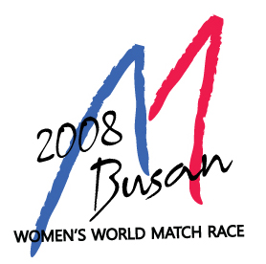
BUSAN SAILING FEDERATION
1393, Woo-1dong, Haeundae-gu, Busan Korea
Tel. : +82 51 747 1768 FAX : +82 51 746 1793
www.bsaf.or.kr e-mail: committee@bsaf.or.kr

2008 BUSAN WOMEN’S WORLD MATCH RACE ISAF GR. 1
ACCEPTANCE OF INVITATION

Please fill in the following form and either fax or e-mail it to Busan Sailing Federation

SKIPPER

Name and surname
Nationality
Ranking Position
ISAF Sailor ID
Address
E-mail address
Telephone number
Club

CREWS
Name and Surname |  | Nationality | Club
DECLARATION
I agree to be bound to the I.S.A.F. and RFEV. Rules, under which jurisdiction this regatta is sailed; to the Regatta Instructions and to the class Rules, I declare to undertake every responsibility on myself for damages to the persons and to my own or third parties things, at sea or ashore, in consequence of my participation in the regatta. In order to take part to the race I also declare to have all the physical requisites, as specified in the health certificate and to sail at my own risk taking upon myself all responsibility.
DATE | SIGNATURE

□I authorize payment of USD $1,500 on my credit card:
Visa □ Master Card □

Name of card owner: ___________________________

Card number: ___________________________

Expiry date: ___________________________

Signature: ___________________________

□I pay USD $1,500 by bank transfer (free of expense for beneficiary) and I send you a copy here with.
SWIFT CODE: PUSBKR2P
BANK NAME: PUSAN BANK
BRANCH NAME: NURIMARU BRANCH
A/C NO.: 171-54-000116-6
A/C NAME: BSAF

